**Clinical Decision Support (CDS) Content and Health Level 7 (HL7)-Compliant Knowledge Artifacts (KNARTs)**

**Mental Health: Consult for Depression Clinical Content White Paper**

**Department of Veterans Affairs (VA)**



**Knowledge Based Systems (KBS)**

**Office of Informatics and Information Governance (OIIG)**

**Clinical Decision Support (CDS)**

**Clinical Decision Support (CDS) Content and Health Level 7 (HL7)-Compliant Knowledge Artifacts (KNARTs): Mental Health: Consult for Depression Clinical Content White Paper**

by Department of Veterans Affairs (VA)

Publication date April 2018

**Contract: VA118-16-D-1008, Task Order (TO): VA-118-16-F-1008-0007**

**Table 1. Relevant KNART Information: Mental Health: Consult for Depression**

| **Mental Health** | **Associated CLIN** |
| --- | --- |
| Consult for Depression - Order Set | CLIN0004AB |
| Consult for Depression - Documentation Template/Consult Request | CLIN0005AB |
| Consult for Depression – Composite/Consult Request | N/A |

**Table of Contents**

VA Subject Matter Expert (SME) Panel vi

Introduction vii

Conventions Used viii

1. Mental Health: Consult for Depression 1

1.1. Clinical Context 1

1.2. Knowledge Artifacts 1

2. Composite: Consult for Depression Consult Request 2

2.1. Knowledge Narrative 2

2.2. Consult and Referral Request 2

3. Documentation Template: Consult for Depression 4

3.1. Knowledge Narrative 4

3.2. Screening Mental Health Evaluation 4

3.3. Medical History 6

3.4. Treatment History 6

4. Order Set: Consult for Depression 7

4.1. Knowledge Narrative 7

4.2. Consults and Referrals 7

4.3. Patient and Caregiver Education 7

Bibliography/Evidence 8

A. Existing Sample VA Artifacts 9

Acronyms 42

**List of Figures**

A.1. Mental Health Depression (MHD) Consult 9

A.2. Template MHD Consult 10

A.3. Template MHD Consult  11

A.4. Order a MHD Outpatient Consult 11

A.5. Template MHD Consult – E-Consult 12

A.6. Template MHD Consult – E-Consult 13

A.7. Order a MHD Outpatient E-Consult 14

A.8. I am NOT a Mental Health Provider 14

A.9. Emergency to be seen by Emergency Department Psychiatrist 15

A.10. Reason for Request- Mental Health Psychiatry Emergency Outpt. (WLA) 16

A.11. Reason for Request- Mental Health Clinic Outpt. (WLA) 17

A.12. Reason for Request- Mental Health Clinic Outpt. (WLA) Continued 18

A.13. Reason for Request- Mental Health Clinic Outpt. (WLA) Continued 19

A.14. Reason for Request- Mental Health Clinic Outpt. (WLA) Continued 20

A.15. Mental Health Consult from Specialty Clinics 21

A.16. Mental Health Consult from Specialty Clinics Continued 21

A.17. Reason for Request- Geropsych Clinic Outpt. (WLA) 22

A.18. Reason for Request- Geropsych Clinic Outpt. (WLA) Continued 23

A.19. Reason for Request- Geropsych Clinic Outpt. (WLA) Continued 24

A.20. Mental Health Consult from Specialty Clinics 25

A.21. Mental Health Consult for Medical or Surgical Inpatient 25

A.22. Template Depression Assessment Consult Note 26

A.23. Template Depression Assessment Consult Note Continued 27

A.24. Template Depression Assessment Consult Note Continued 28

A.25. Template Depression Assessment Consult Note Continued 29

A.26. Template Depression Assessment Consult Note Continued 30

A.27. Reminder Dialog Template 31

A.28. Reminder Dialog Template: GRECC Exam Tools 32

A.29. Geriatric Depression Scale (GDS) ZZTEST 33

A.30. GDS ZZTEST Continued 34

A.31. Reminder Dialog Template: GRECC Exam Tools 35

A.32. PHQ-2: ZZTEST 36

A.33. VISN-Depression Screen 37

A.34. VISN-Depression Screen What has changed, and why? 37

A.35. VISN-Depression Screen Performing the Depression Screen 38

A.36. VISN-Depression Screen PHQ-2 Instrument 38

A.37. VISN-Depression Screen Negative Result 39

A.38. VISN-Depression Screen Finish 39

A.39. VISN-Depression Screen Positive Result 40

**List of Tables**

1. Relevant KNART Information: Mental Health: Consult for Depression ii

1.1. Clinical Context Domains 1

**VA Subject Matter Expert (SME) Panel**

| **Name** | **Title** | **Project Role** |
| --- | --- | --- |
| William Becker, MD | Internist, West Haven, CT | SME, Primary |
| Katy Lysell, MD | National Mental Health Director for Informatics, Honolulu, HI 96819 | SME, Secondary |
| Elizabeth Oliva | VA National OEND Coordinator VA Palo Alto Health Care System Menlo Park, VA 04025 | SME |
| Kendall Browne, MD | Post-Doctoral Fellow VAPSHCS – Seattle, Seattle, WA 08108 | SME |
| Rani Hoff, PhD, MPH | Director, Northeast Program Evaluation Center Office of Mental Health and Suicide Prevention (10NC5) VA Central Office (VACO); Professor of Psychiatry Yale University School of Medicine | SME |

**Introduction**

The VA is committed to improving the ability of clinicians to provide care for patients while increasing quality, safety, and efficiency. Recognizing the importance of standardizing clinical knowledge in support of this goal, VA is implementing the Health Level 7 (*HL7*) Knowledge Artifact Specification for a wide range of VA clinical use cases. Knowledge Artifacts, referred to as (*KNARTs*), enable the structuring and encoding of clinical knowledge so the knowledge can be integrated with electronic health records to enable clinical decision support.

The purpose of this Clinical Content White Paper (*CCWP*) is to capture the clinical context and intent of *KNART* use cases in sufficient detail to provide the *KNART* authoring team with the clinical source material to construct the corresponding knowledge artifacts using the HL7 Knowledge Artifact Specification. This paper has been developed using material from a variety of sources: VA artifacts, clinical practice guidelines, evidence in the body of medical literature, and clinical expertise. After reviewing these sources, the material has been synthesized and harmonized under the guidance of VA subject matter experts to reflect clinical intent for this use case.

Unless otherwise noted, items within this white paper (e.g., documentation template fields, orderable items, etc.) are chosen to reflect the clinical intent at the time of creation. To provide an exhaustive list of all possible items and their variations is beyond the scope of this work.

**Conventions Used**

Conventions used within the knowledge artifact descriptions include:

<obtain>: Indicates a prompt to obtain the information listed

* If possible, the requested information should be obtained from the underlying system(s). Otherwise, prompting the user for information may be required
* Default Values: Unless otherwise noted, <obtain> indicates to obtain the most recent observation. It is recognized that this default time-frame value may be altered by future implementations

[...]: Square brackets enclose explanatory text that indicates some action on the part of the clinical user, or general guidance to the clinical or technical teams. Examples include, but are not limited to:

[Begin ...], [End ...]: Indicates the start and end of specific areas to clearly delineate them for technical purposes.

[Activate ...]: Initiates another knowledge artifact or knowledge artifact section.

[Section Prompt: ...]: If this section is applicable, then the following prompt should be displayed to the user.

[Section Behavior: ...]: Indicates technical constraints or considerations for the selection of items outlined in the section prompt.

[Attach: ...]: Indicates that the specified item (e.g. procedure or result interpretation) should be attached to the documentation template if available.

[Link: ...]: Indicates that rather than attaching an item (e.g. image), a link should be included in the documentation template.

[Clinical Comment: ...]: Indicates technical considerations or notes to be utilized for KNART authoring and at time of implementation planning.

[Technical Note: ...]: Indicates technical considerations or notes to be utilized for KNART authoring and at time of implementation planning.

[If ...]: Indicates the beginning of a conditional section.

[Else, ...]: Indicates the beginning of the alternative branch of a conditional section.

[End if ...]: Indicates the end of a conditional section.

☐ [Check box]: Indicates items that should be selected based upon the section selection behavior.

**Chapter 1. Mental Health: Consult for Depression**

**1.1. Clinical Context**

[Begin Clinical Context.]

This set of KNARTs is intended to support initiation of appropriate clinical orders and provision of required documentation to place a consult request.

Depression is a highly prevalent condition that is among the most common causes of morbidity, mortality (i.e., suicide, homicide), and disability. In view of this, the VA has established structured protocols for collaborative care management that are generally implemented by behavioral health nurses or clinical social workers, with provision for referral to specialty mental health care programs when needed.

**Table 1.1. Clinical Context Domains**

|  |  |
| --- | --- |
| Target User | Primary Care Providers (PCPs) and Mental Health Providers embedded in primary care practice settings |
| Patient | Adults outpatients identified as requiring evaluation or treatment for depression |
| Priority | Routine |
| Specialty | Primary Care |
| Location | Outpatient |

[End Clinical Context.]

**1.2. Knowledge Artifacts**

[Begin Knowledge Artifacts.]

This section describes the CDS knowledge artifacts that are part of the Mental Health group, and include:

* A Composite/Consult Request: Mental Health: Consult for Depression KNART
* High-level, encompassing artifact
* Relies upon the documentation template and order set artifacts
* A Documentation Template: Mental Health: Consult for Depression KNART
* Documents the information provided by the referring provider
* Includes logic for appropriate display of documentation sections
* An Order Set: Mental Health: Consult for Depression KNART
* Orderable items associated with the consult request
* Includes logic for appropriate display of the order set

[End Knowledge Artifacts.]

**Chapter 2. Composite/Consult Request: Consult for Depression**

[Begin Composite/Consult Request: Consult for Depression.]

**2.1. Knowledge Narrative**

[Begin Knowledge Narrative.]

[See Clinical Context in Chapter 1.]

[End Knowledge Narrative.]

**2.2. Consult and Referral Request**

[Begin Consult and Referral Request.]

[Technical Note: The following list provides the basic components of the consult request. This is the high-level, encompassing artifact, and must be combined with the documentation template and order set to form a fully functional knowledge artifact.]

[Technical Note: Consult specialty of mental health should be selected automatically]

[Section Prompt: Consult Specialty: Mental Health]

<obtain> Reason for consult

[Section Prompt: Goal of Consult.]

[Section Selection Behavior: Required. Select One.]

☐ Return to PCP for therapy

☐ Start treatment and return to PCP for follow up and maintenance

☐ Start treatment, monitor for effect and when on stable therapy return to PCP

☐ Treat as long as necessary (or indefinitely)

[Section Prompt: Priority.]

☐ Routine (within 30 days)

☐ Routine with Scheduling Instructions

[Technical Note: Obtain from Documentation Template.]

<obtain> Current psychiatric medications

[Section Prompt: Patient Treatment Preference.]

[Section Selection Behavior: Select one or more. Required.]

☐ Psychotherapy

☐ Medication

☐ Medication and psychotherapy

☐ No preference

<obtain> Additional information

[Technical Note: Obtain from Documentation Template or input by ordering provider.]

<obtain> Referring Physician

<obtain> Referring Physician Contact Information

[Technical Note: Referring Physician and Referring Physician Contact Information to be filled in automatically.]

[End Consult and Referral Request.]

[End Composite Consult/Request: Consult for Depression.]

**Chapter 3. Documentation Template: Consult for Depression**

[Begin Documentation Template: Consult for Depression.]

[Technical Note: This documentation template should be available to PCPs and mental health providers embedded in primary care practice settings caring for outpatients identified as requiring evaluation or treatment for depression.]

**3.1. Knowledge Narrative**

[Begin Knowledge Narrative.]

[See Clinical Context in Chapter 1.]

[End Knowledge Narrative.]

**3.2. Screening Mental Health Evaluation**

[Begin Screening Mental Health Evaluation.]

[Section Prompt: Patient Health Questionnaire-9 (PHQ-9). (A score of 10 is considered the threshold for mild symptoms of depression.)]

[Technical Note: Both the most recent PHQ-9 score from any timeframe and all PHQ-9 scores from the past 1 year should be presented to the user, with the dates of those scores, from available data.]

[Technical Note: PHQ-9 must be calculated by totaling the form label values (displayed below following each user selection option) for the form labels selected by the user. Note that the following form components are adapted from Kroenke 2001. A score of 10 is considered the threshold for mild symptoms of depression.]

[Section Selection Behavior: Select one for each question asked. Optional.]

[Technical Note: PHQ-9 score calculated using numbers following the response options below. Use the following reference link for scoring: https://www.integration.samhsa.gov/images/res/PHQ%20-%20Questions.pdf.]

[Section Prompt: Patient response to "over the past two weeks, how often have you been bothered by any of the following problems?"]

[Section Prompt: "Little interest or pleasure in doing things."]

☐ Not at all 0

☐ Several days 1

☐ More than half the days 2

☐ Nearly every day 3

[Section Prompt: “Feeling down, depressed, or hopeless.”]

☐ Not at all 0

☐ Several days 1

☐ More than half the days 2

☐ Nearly every day 3

[Section Prompt: "Trouble falling or staying asleep, or sleeping too much."]

☐ Not at all 0

☐ Several days 1

☐ More than half the days 2

☐ Nearly every day 3

[Section Prompt: "Feeling tired or having little energy."]

☐ Not at all 0

☐ Several days 1

☐ More than half the days 2

☐ Nearly every day 3

[Section Prompt: "Poor appetite or overeating."]

☐ Not at all 0

☐ Several days 1

☐ More than half the days 2

☐ Nearly every day 3

[Section Prompt: "Feeling bad about yourself-or that you are a failure or have let yourself or your family down."]

☐ Not at all 0

☐ Several days 1

☐ More than half the days 2

☐ Nearly every day 3

[Section Prompt: "Trouble concentrating on things, such as reading the newspaper or watching television."]

☐ Not at all 0

☐ Several days 1

☐ More than half the days 2

☐ Nearly every day 3

[Section Prompt: "Moving or speaking so slowly that other people could have noticed. Or the opposite-being so fidgety or restless that you have been moving around a lot more than usual."]

☐ Not at all 0

☐ Several days 1

☐ More than half the days 2

☐ Nearly every day 3

[Section Prompt: "Thoughts that you would be better off dead or of hurting yourself."]

☐ Not at all 0

☐ Several days 1

☐ More than half the days 2

☐ Nearly every day 3

[Technical Note: The following question should be presented if PHQ-9 score >= 1. Note that this is an unscored question in the PHQ-9 and has no form label value.]

Patient response to “If you checked off any problems, how difficult have these problems made it for you to do your work, take care of things at home, or get along with other people?”

☐ Not difficult at all

☐ Somewhat difficult

☐ Very difficult

☐ Extremely difficult

[Section Prompt: Suicide Risk.]

[Section Prompt: Prompt user to follow VA protocol for emergency situations. Information about the Veterans Crisis Line should be provided as appropriate, including the telephone number (800.273.8255), text message support (838255), and the website (https://www.veteranscrisisline.net/).]

☐ The patient has a current, active suicidal ideation plan in place.

[Technical Note: Provide link to “Mental Health – Suicide Risk Assessment” documentation template KNART.]

[Technical Note: Link to suicide screen, which should be displayed automatically if the checkbox for a current active plan for suicide is selected.]

<obtain> Additional information

[End Screening Mental Health Evaluation.]

**3.3. Medical History**

[Begin Medical History.]

[Technical Note: Thyroid study results from the past 1 year should be autopopulated, with the dates of those results.]

<obtain> Thyroid-stimulating hormone (TSH), free T4 results and dates

<obtain> Additional Information

[End Medical History.]

**3.4. Treatment History**

[Begin Treatment History.]

<obtain> Interventions tried prior to consult request (timeframes, intensities, and providers for psychotherapy and any other interventions)

[End Treatment History.]

[End Documentation Template: Consult for Depression.]

**Chapter 4. Order Set: Consult for Depression**

[Begin Order Set: Consult for Depression.]

**4.1. Knowledge Narrative**

[Begin Knowledge Narrative.]

[See Clinical Context in Chapter 1.]

[End Knowledge Narrative.]

**4.2. Consults and Referrals**

[Begin Consults and Referrals.]

[Section Prompt: Follow VA protocol for emergency situations. Information about the Veterans Crisis Line should be provided to the patient as appropriate, including the telephone number (800.273.8255), text message support (838255), and the website (https://www.veteranscrisisline.net/).]

[Technical Note: This section should be provided to PCPs and mental health providers embedded in primary care practice settings who are caring for outpatients identified as requiring evaluation or treatment for depression.]

[Section Prompt: Inform patient that referral order was placed, including location of consult and emergency contact details for informed consent and contingency planning.]

☐ Referral to mental health to evaluate and treat for depression (routine-within 30 days)

[End Consults and Referrals.]

**4.3. Patient and Caregiver Education**

[Begin Patient and Caregiver Education.]

[Technical Note: This section should be provided to primary care providers and mental health providers embedded in primary care practice settings who are caring for outpatients identified as requiring evaluation or treatment for depression.]

☐ Depression education now

[End Patient and Caregiver Education.]

[End Order Set: Consult for Depression.]

**Bibliography/Evidence**

[Arrol, 2010] B Arroll, F Goodyear-Smith, S Crengle, J Gunn, N Kerse, T Fishman, K Falloon, and S Hatcher. “Validation of PHQ-2 and PHQ-9 to screen for major depression in the primary care population”. *Ann Fam Med*. 2010. 8. 4. 348-353.

[Dundon, 2011] M Dundon, K Dollar, M Schohn, and LJ Lantinga. “Primary Care-Mental Health Integration Co-Located, Collaborative Care: An Operations Manual”. *U.S. Department of Veterans Affairs Mental Illness Research, Education and Clinical Centers (MIRECC)/Centers of Excellence (CoE) website*. <https://www.mirecc.va.gov/cih-visn2/Documents/Clinical/MH-IPC_CCC_Operations_Manual_Version_2_1.pdf>. Updated March 2011.

[Kroenke, 2001] K Kroenke, RL Spitzer, and JB Williams. “The PHQ-9: validity of a brief depression severity measure”. *J Gen Intern Med*. 2001. 16. 9. 606-613.

*Primary Care Mental Health Integration (PCMHI): Providing Same Day Access to Mental Health*. *U.S. Department of Veterans Affairs Mental Illness Research, Education and Clinical Centers (MIRECC)/Centers of Excellence (CoE) website*. <https://www.mirecc.va.gov/cih-visn2/Documents/Clinical/PCMHI_Same_Day_Access_Options_for_Implementation.pdf>. Accessed October 5, 2017.

[Siu, 2016] AL Siu, K Bibbins-Domingo, DC Grossman, and et al. “US Preventive Services Task Force (USPSTF). Screening for Depression in Adults: US Preventive Services Task Force Recommendation Statement”. *JAMA*. 2016. 315. 4. 380-387.

[Thibault, 2004] JM Thibalut and RW Steiner. “Efficient identification of adults with depression and dementia”. *Ann Fam Physician*. 2004. 70. 6. 1101-1110.

**Appendix A. Existing Sample VA Artifacts**

Figures A.1-A.7: Portland Oregon VA Medical Center (VAMC) Screenshots: Mental Health Consult for Depression - Order Set

**Figure A.1. Mental Health Depression (MHD) Consult (image 1 of 3)**

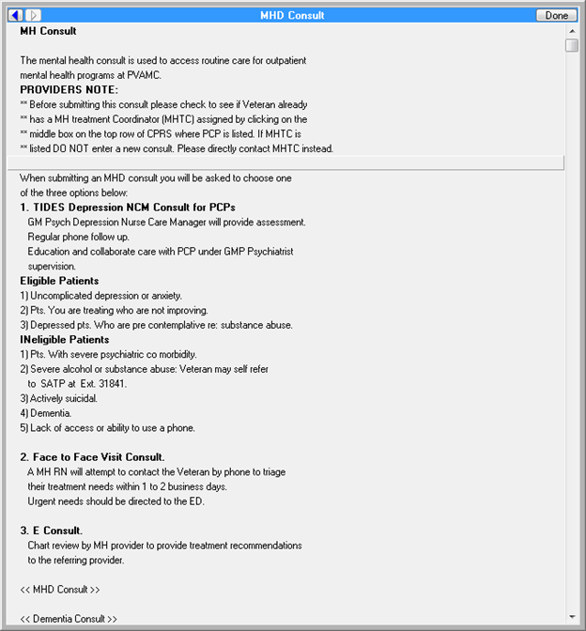

**Figure A.2. Template Mental Health Depression (MHD) Consult (image 2 of 3)**

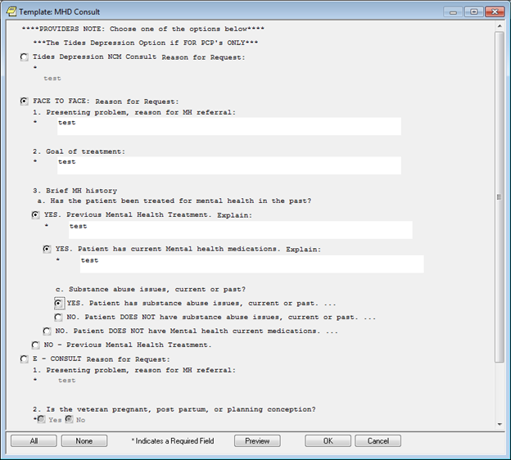

**Figure A.3. Template Mental Health Depression (MHD) Consult (image 3 of 3)**

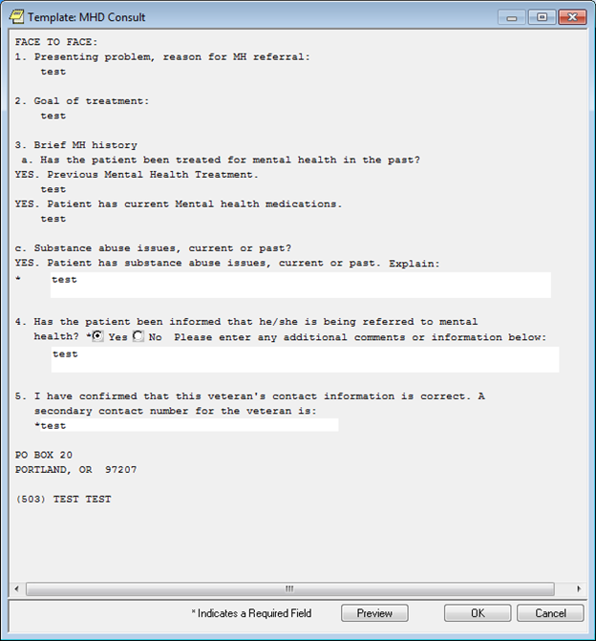

**Figure A.4. Order a Mental Health Depression (MHD) Outpatient Consult**

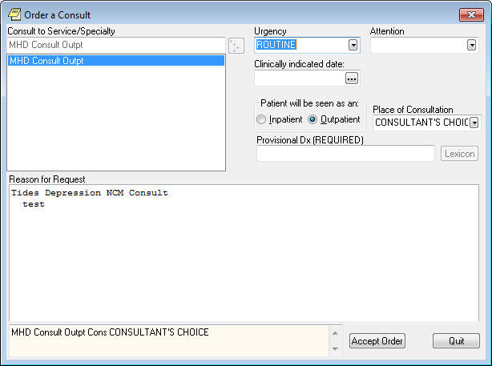

**Figure A.5. Template Mental Health Depression (MHD) Consult -– E-Consult (image 1 of 2)**

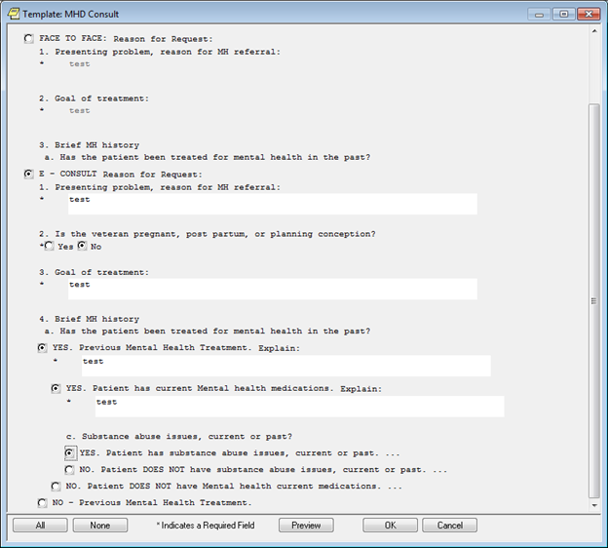

**Figure A.6. Template Mental Health Depression (MHD) Consult -– E-Consult (image 2 of 2)**

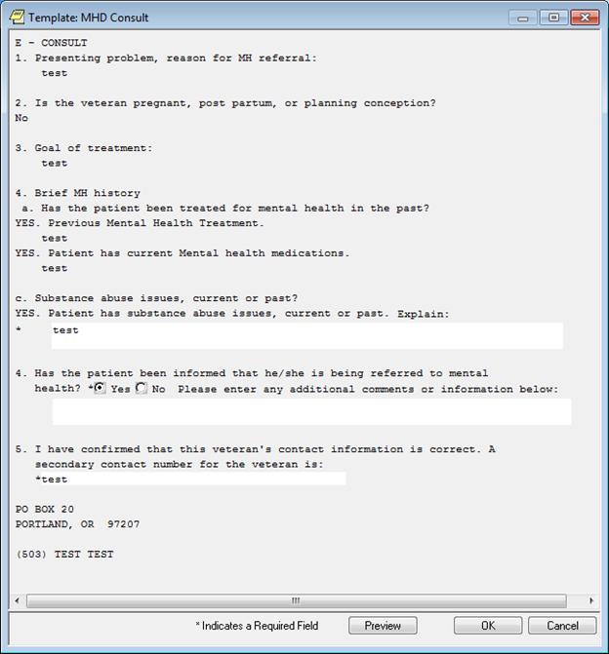

**Figure A.7. Order a Mental Health Depression (MHD) Outpatient E-Consult**

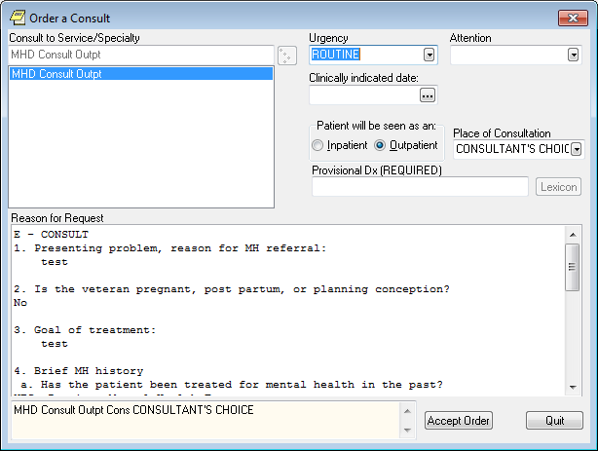

Figures A.8-A.21: Greater Los Angeles, CA VAMC Screenshots Mental Health Depression - Order Set

**Figure A.8. I am NOT a Mental Health Provider**

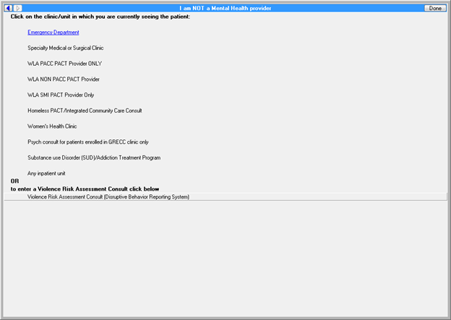

**Figure A.9. Emergency to be Seen by Emergency Department Psychiatrist**

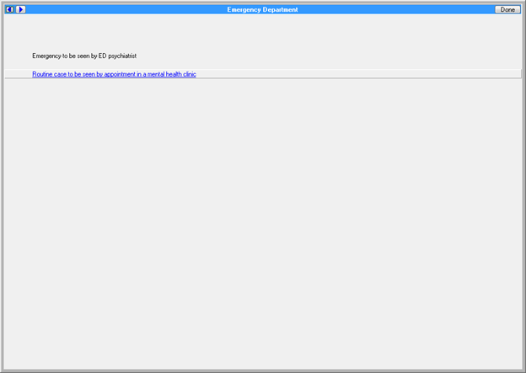

**Figure A.10. Reason for Request - Mental Health Psychiatry Emergency Outpatient**

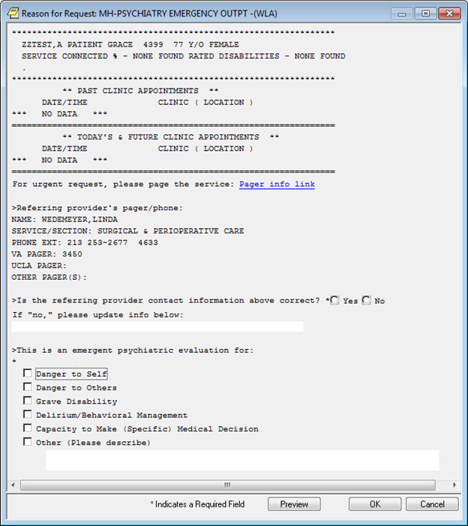

**Figure A.11. Reason for Request - Mental Health Clinic Outpatient (image 1 of 4)**

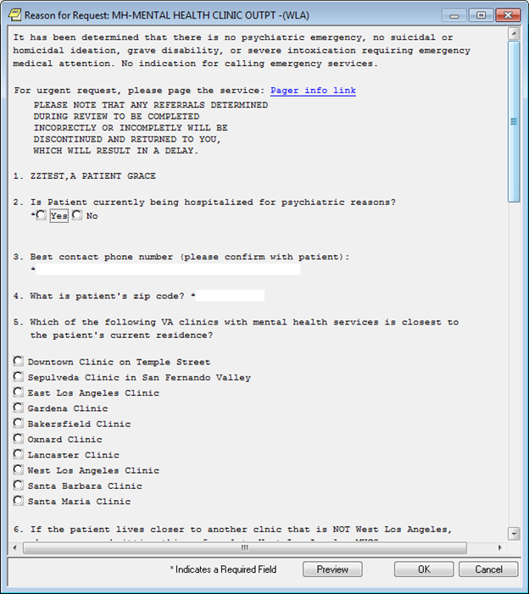

**Figure A.12. Reason for Request - Mental Health Clinic Outpatient (image 2 of 4)**

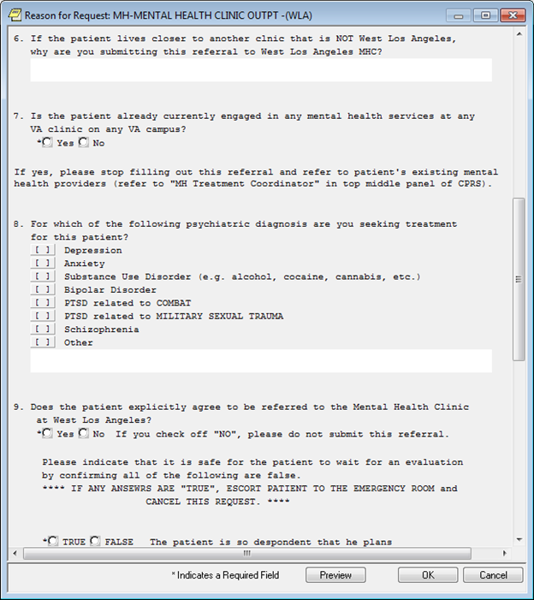

**Figure A.13. Reason for Request - Mental Health Clinic Outpatient (image 3 of 4)**

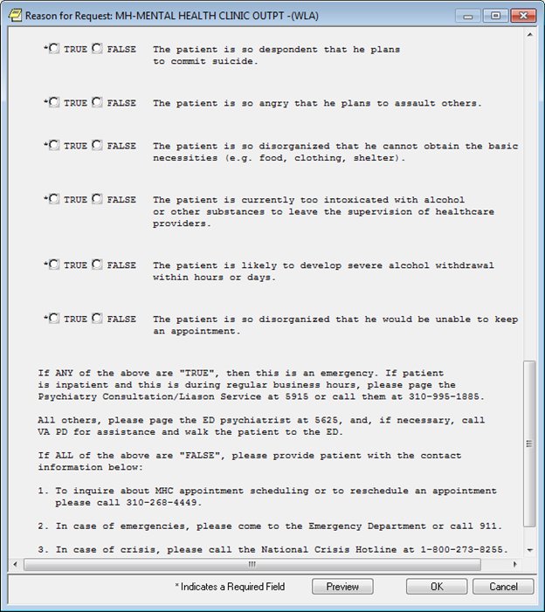

**Figure A.14. Reason for Request - Mental Health Clinic Outpatient (image 4 of 4)**

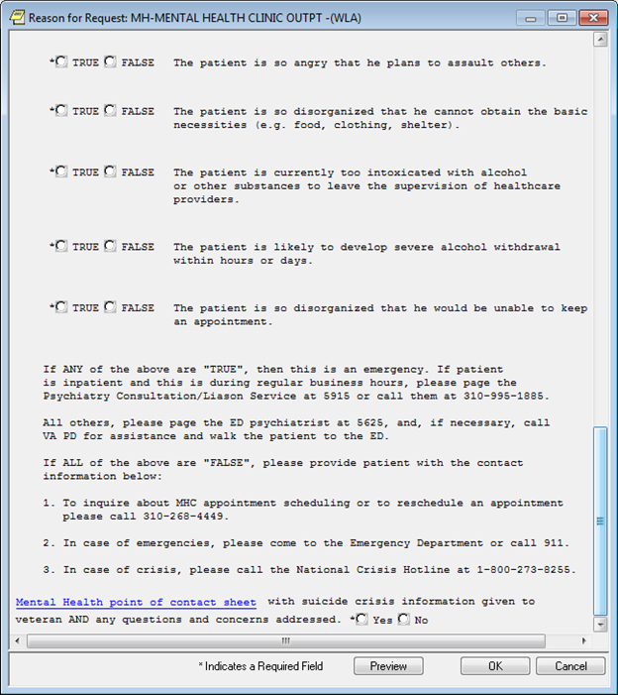

**Figure A.15. Mental Health Consult from Specialty Clinics, for Patients Older Than 65 with Multiple Medical Problems (image 1 of 2)**

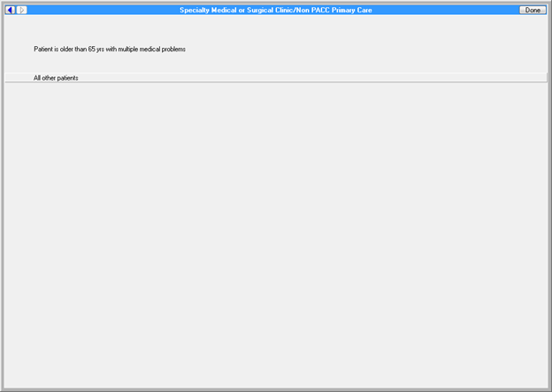

**Figure A.16. Mental Health Consult from Specialty Clinics, for Patients Older Than 65 with Multiple Medical Problems (image 2 of 2)**

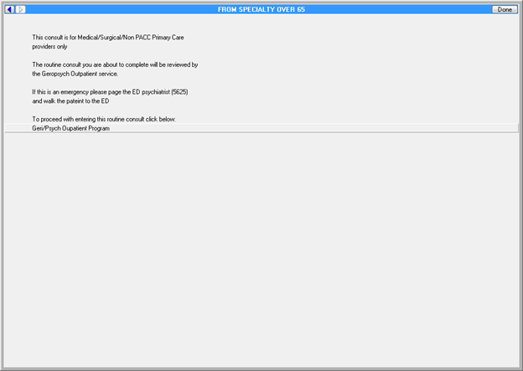

**Figure A.17. Reason for Request - Geropsychiatry Clinic Outpatient (image 1 of 3)**

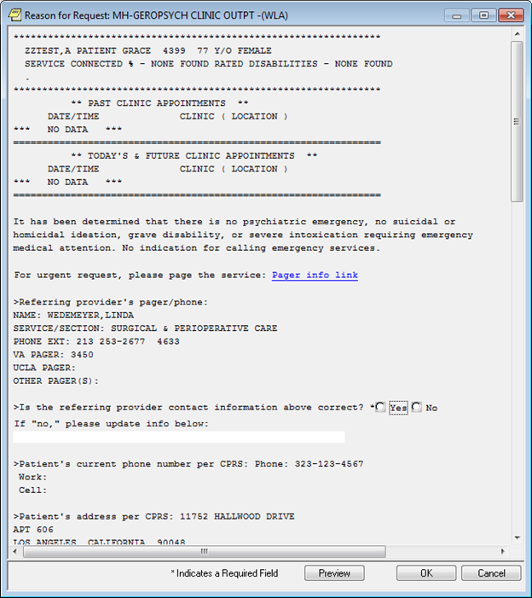

**Figure A.18. Reason for Request- Geropsychiatry Clinic Outpatient (image 2 of 3)**

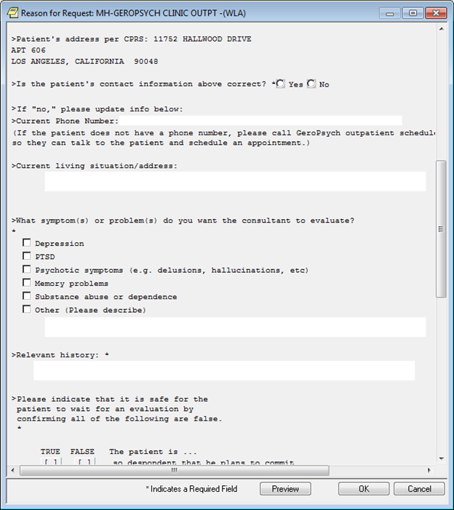

**Figure A.19. Reason for Request - Geropsychiatry Clinic Outpatient (image 3 of 3)**

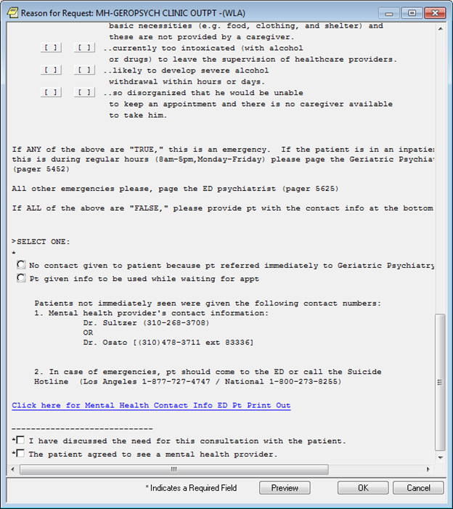

**Figure A.20. Mental Health Consult from Specialty Clinics**

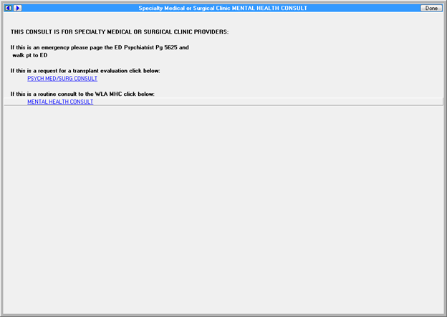

**Figure A.21. Mental Health Consult for Medical or Surgical Inpatient**

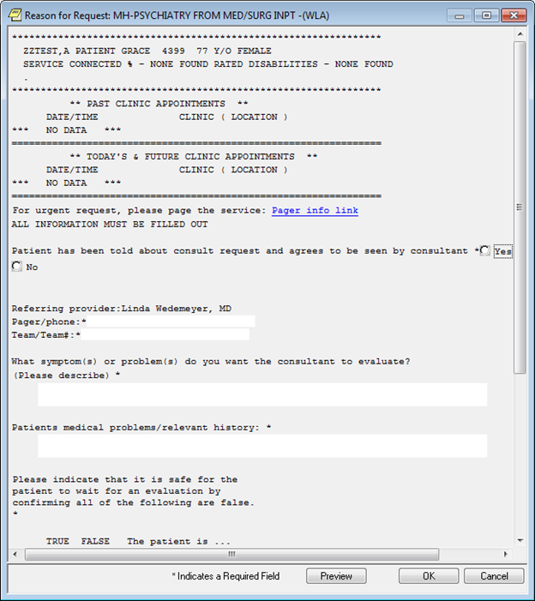

Figures A.22-A.32: Greater Los Angeles, CA VAMC Mental Health Consult for Depression - Documentation Template

**Figure A.22. Template: Depression Assessment Consult Note (image 1 of 5)**

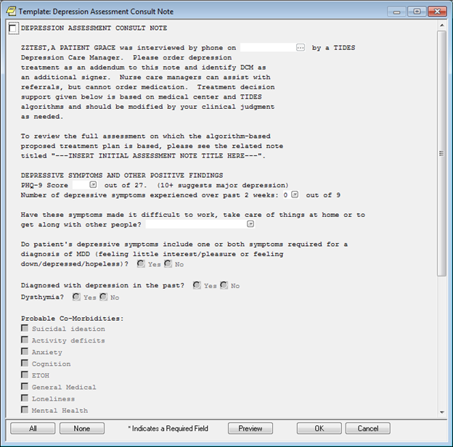

**Figure A.23. Template: Depression Assessment Consult Note (image 2 of 5)**

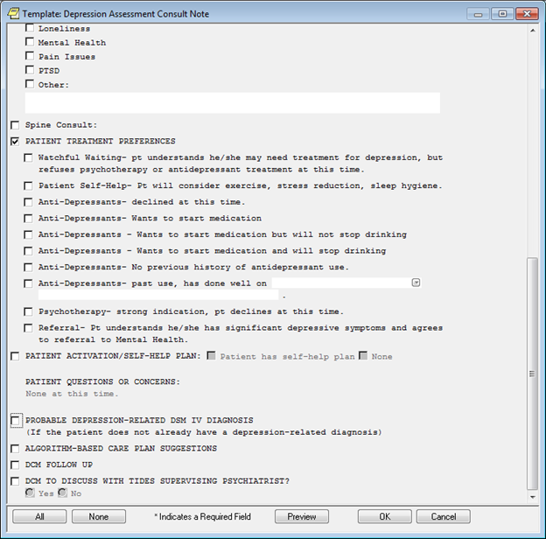

**Figure A.24. Template: Depression Assessment Consult Note (image 3 of 5)**

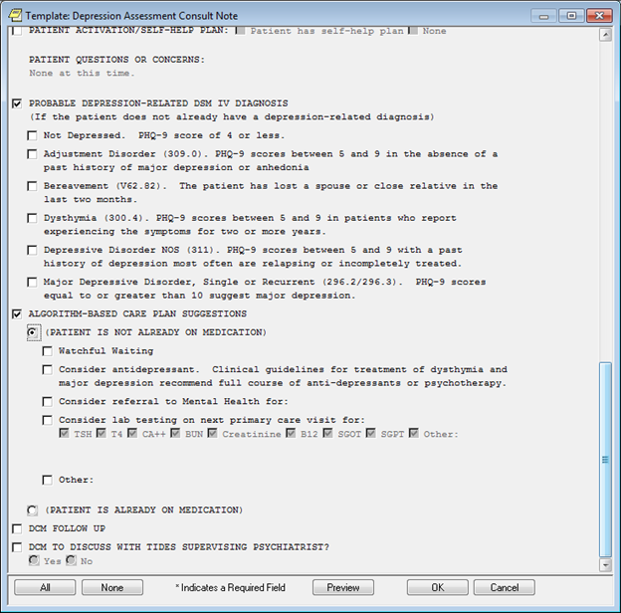

**Figure A.25. Template: Depression Assessment Consult Note (image 4 of 5)**

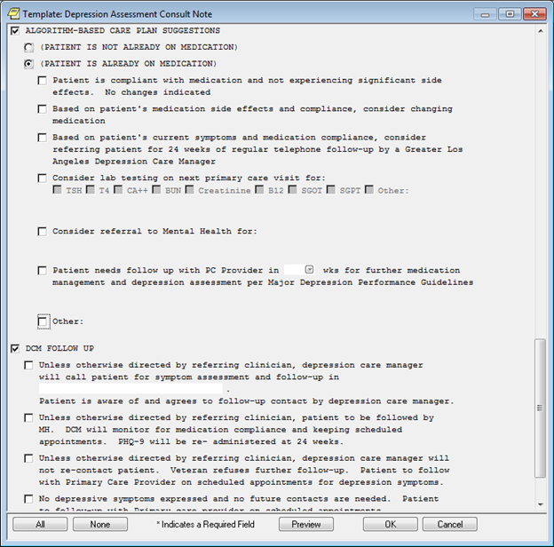

**Figure A.26. Template: Depression Assessment Consult Note (image 5 of 5)**

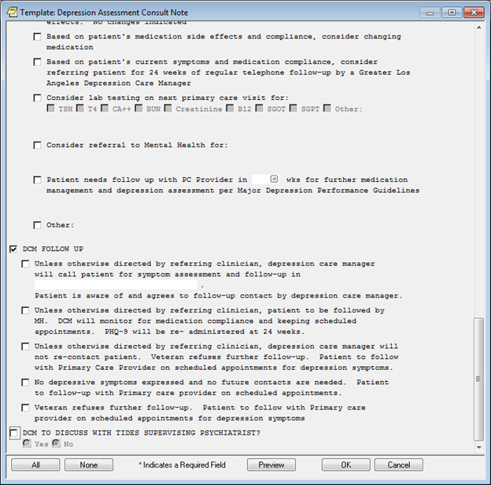

**Figure A.27. Reminder Dialog Template: Geriatric Research Education and Clinical Center (GRECC) Exam Tools (image 1 of 2)**

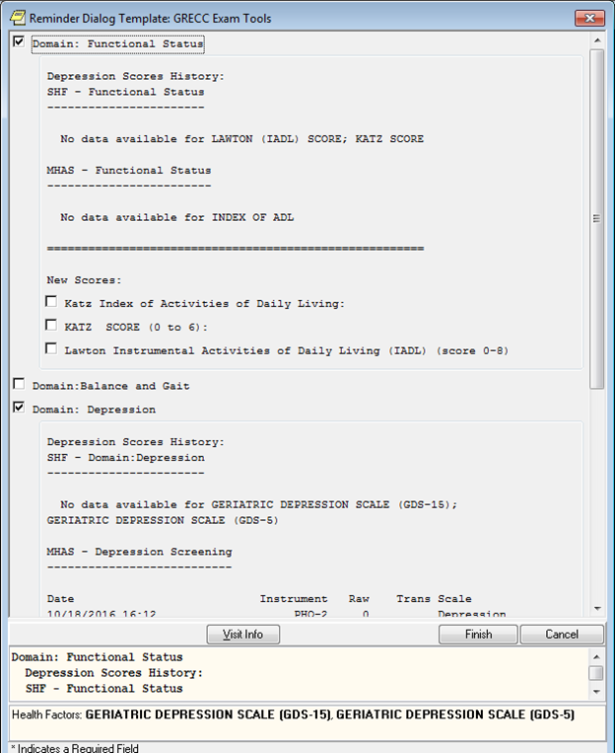

**Figure A.28. Reminder Dialog Template: Geriatric Research Education and Clinical Center (GRECC) Exam Tools (image 2 of 2)**

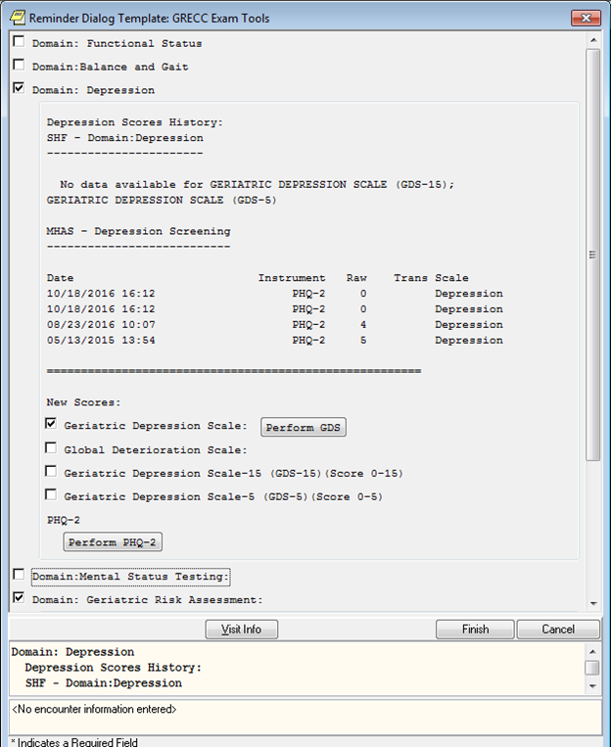

**Figure A.29. Geriatric Depression Scale (GDS) Test (image 1 of 2)**

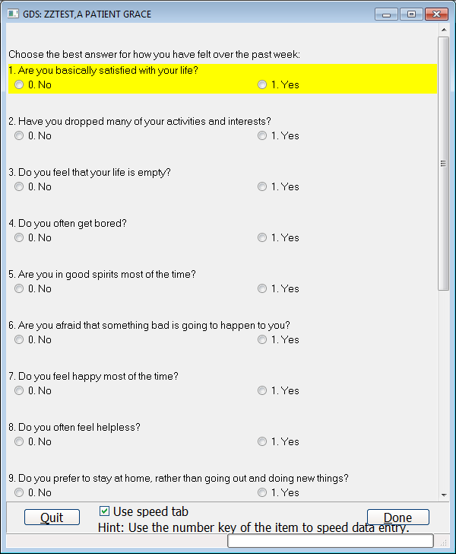

**Figure A.30. Geriatric Depression Scale (GDS) Test (image 2 of 2)**

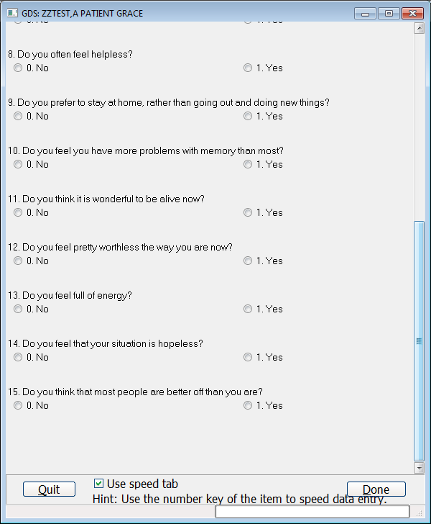

**Figure A.31. Reminder Dialog Template: Geriatric Research Education and Clinical Center (GRECC) Exam Tools – post Geriatric Depression Scale (GDS) Test Completion**

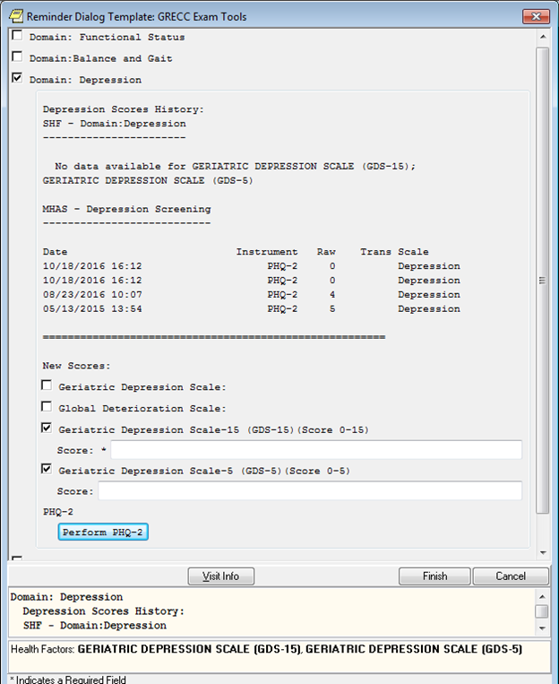

**Figure A.32. Patient Health Questionnaire-2 (PHQ-2)**

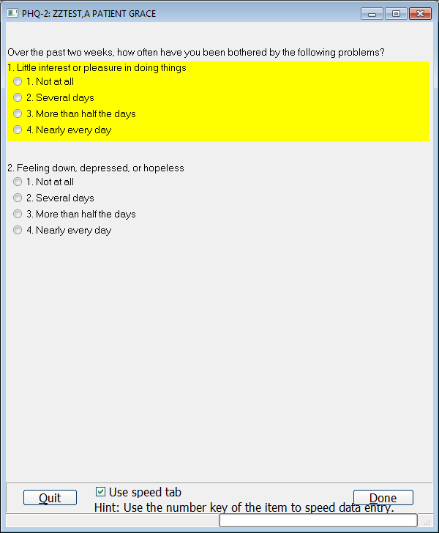

PowerPoint Slides: Veterans Integrated Service Network (VISN) 1 - Depression Evaluation and Follow-up**Figure A.33. Veterans Integrated Service Network (VISN) 1 - Depression Screen (slide 1 of 7)**

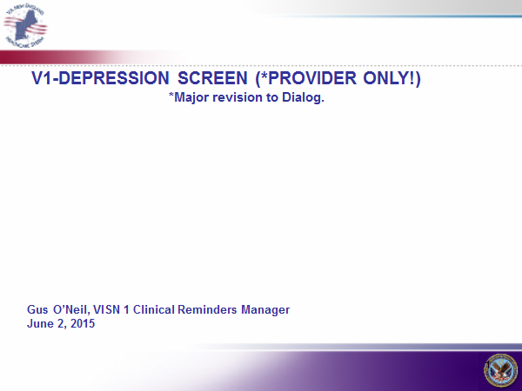

**Figure A.34. Veterans Integrated Service Network (VISN) 1 - Depression Screen: Changes and Rationale (slide 2 of 7)**

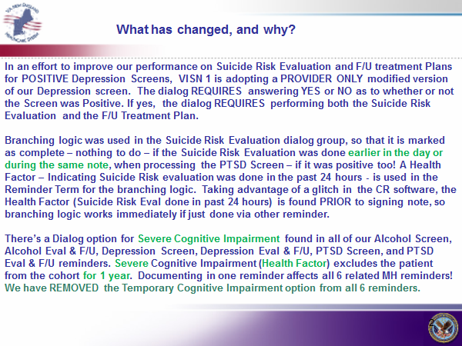

**Figure A.35. Veterans Integrated Service Network (VISN) 1 - Depression Screen: Performing the Depression Screen (slide 3 of 7)**

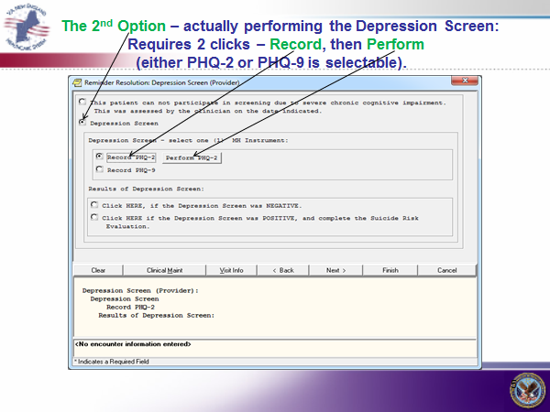

**Figure A.36. Veterans Integrated Service Network (VISN) 1 - Depression Screen: Patient Health Questionnaire-2 (PHQ-2) Instrument (slide 4 of 7)**

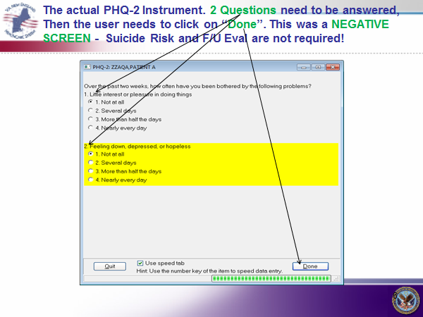

**Figure A.37. Veterans Integrated Service Network (VISN) 1 - Depression Screen: Negative Results (slide 5 of 7)**

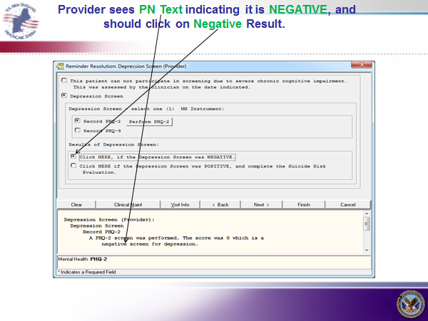

**Figure A.38. Veterans Integrated Service Network (VISN) 1 - Depression Screen: Finish (slide 6 of 7)**

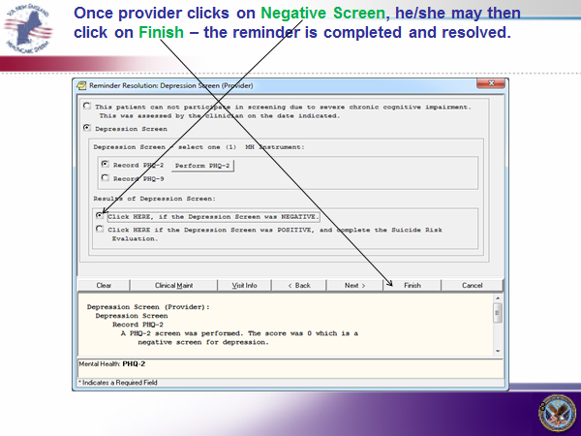

**Figure A.39. Veterans Integrated Service Network (VISN) 1 - Depression Screen: Positive Results (slide 7 of 7)**

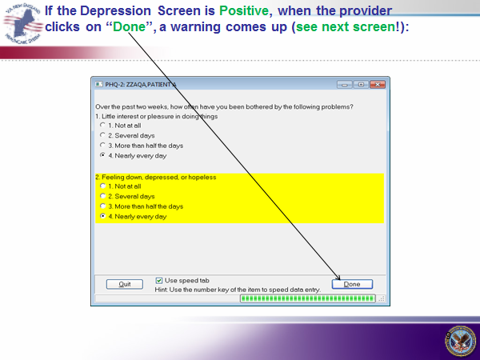

**Acronyms**

CCWP Clinical Content White Paper

CDS Clinical Decision Support

CoE Center of Excellence

GDS Geriatric Depression Scale

GRECC Geriatric Research Education and Clinical Center

HL7 Health Level 7

KNART Knowledge Artifact

MHD Mental Health Depression

MIRECC Mental Illness Research, Education and Clinical Centers

PACC Portland Ambulatory Care Center

PCMHI Primary Care Mental Health Integration

PCP Primary Care Provider

PHQ Patient Health Questionnaire with version number (PHQ-2 and PHQ-9)

SME Subject Matter Expert

TO Task Order

TSH Thyroid-stimulating Hormone

USPSTF United States Preventive Services Task Force

VA Department of Veterans Affairs

VACO VA Central Office

VAMC VA Medical Center

VISN Veterans Integrated Service Network